Snowpipe steps
Create a storage account

Add container (snowflakecsv)

CREATE OR REPLACE DATABASE SNOWPIPE;

-- create integration object that contains the access information
CREATE OR REPLACE STORAGE INTEGRATION azure_snowpipe_integration
TYPE = EXTERNAL_STAGE
STORAGE_PROVIDER = AZURE
ENABLED = TRUE
AZURE_TENANT_ID = '51919faa-a7c3-43e9-bc7d-73c7742bc6a3'
STORAGE_ALLOWED_LOCATIONS = ( ‘azure://snowflakehexamay26.blob.core.windows.net/snowflakecsv');

-- Describe integration object to provide access
DESC STORAGE integration azure_snowpipe_integration;

Set IAM access role assignment

Goto Storage account:
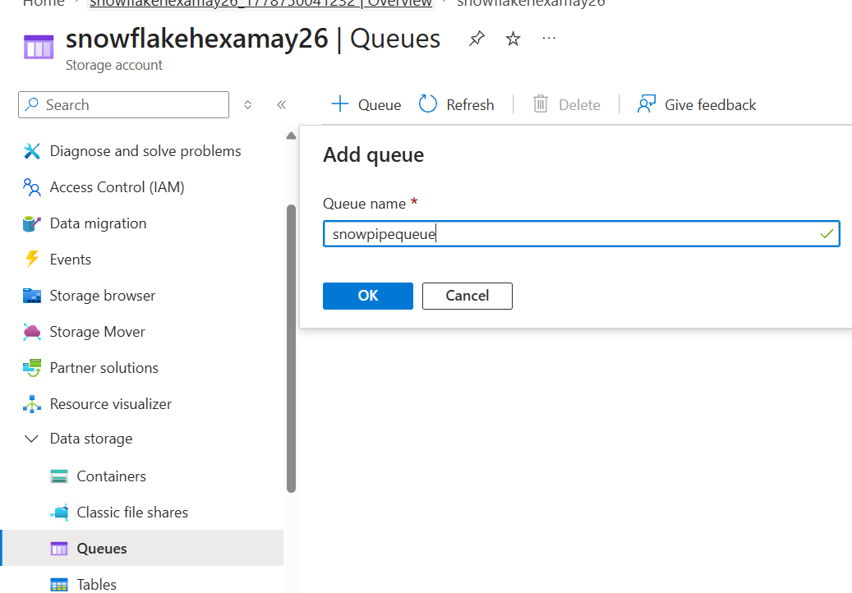
---- Create file format & stage objects ----

-- create file format

create or replace file format snowpipe.public.fileformat_azure
TYPE = CSV
FIELD_DELIMITER = ','
SKIP_HEADER = 1;

-- create stage object
create or replace stage snowpipe.public.stage_azure
STORAGE_INTEGRATION = azure_snowpipe_integration
URL = 'https://<your-container-url>'
FILE_FORMAT = fileformat_azure;

-- list files
LIST @snowpipe.public.stage_azure;

Create Notification Integration

CREATE OR REPLACE NOTIFICATION INTEGRATION snowpipe_event
ENABLED = true
TYPE = QUEUE
NOTIFICATION_PROVIDER = AZURE_STORAGE_QUEUE
AZURE_STORAGE_QUEUE_PRIMARY_URI = 'https://snowflakehexamay26.queue.core.windows.net/snowpipequeue
AZURE_TENANT_ID = '<your-tenant-id>';

-- Register Integration

DESC notification integration snowpipe_event;

After creating queue.

In storageaccount -> events ->Eventsubscription ->

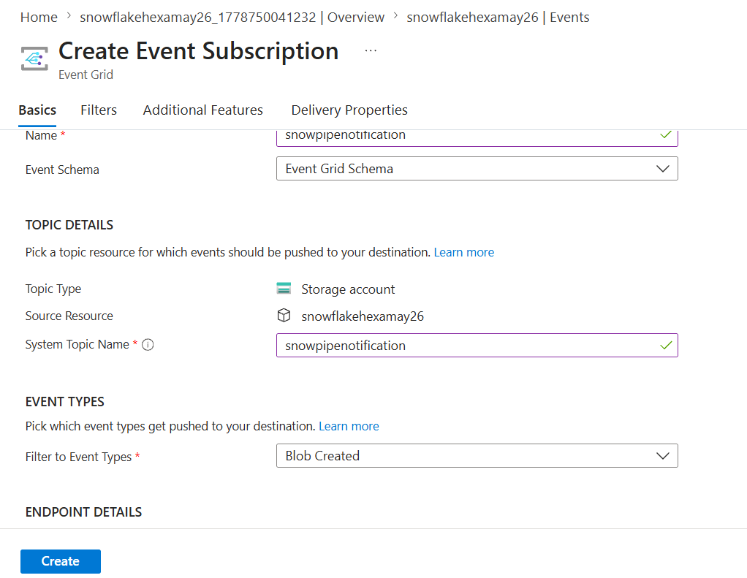

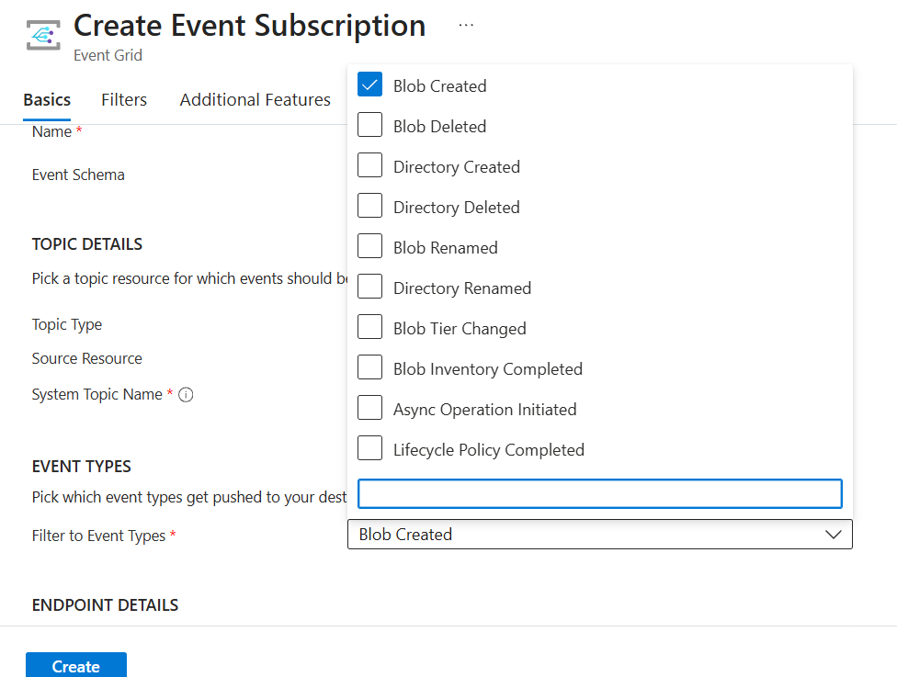

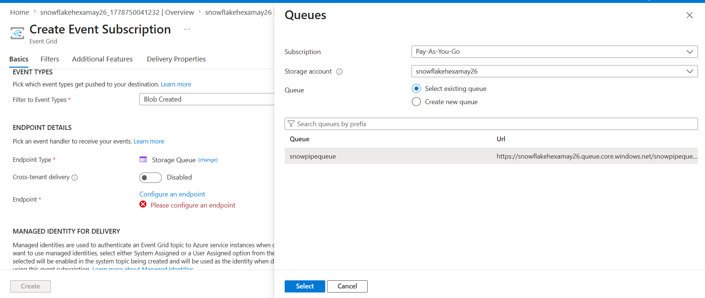

Create

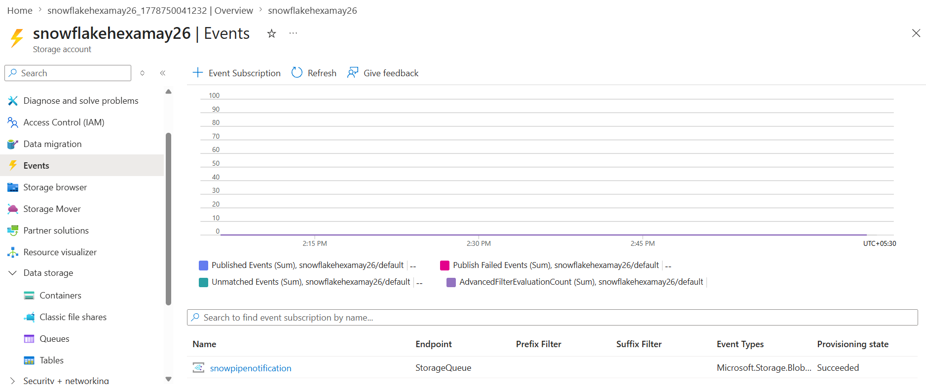

-- list files
LIST @snowpipe.public.stage_azure;

CREATE OR REPLACE NOTIFICATION INTEGRATION snowpipe_event
ENABLED = true
TYPE = QUEUE
NOTIFICATION_PROVIDER = AZURE_STORAGE_QUEUE
AZURE_STORAGE_QUEUE_PRIMARY_URI = 'https://snowflakehexamay26.queue.core.windows.net/snowpipequeue'
AZURE_TENANT_ID = '51919faa-a7c3-43e9-bc7d-73c7742bc6a3';

-- Register Integration

DESC notification integration snowpipe_event;
